The HTML DOM (Document Object Model)

When a web page is loaded, the browser creates a **D**ocument **O**bject **M**odel of the page.

The **HTML DOM** model is constructed as a tree of **Objects**:

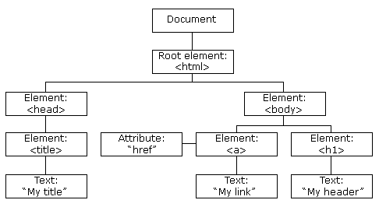

With the object model, JavaScript gets all the power it needs to create dynamic HTML:

* JavaScript can change all the HTML elements in the page
* JavaScript can change all the HTML attributes in the page
* JavaScript can change all the CSS styles in the page
* JavaScript can remove existing HTML elements and attributes
* JavaScript can add new HTML elements and attributes
* JavaScript can react to all existing HTML events in the page
* JavaScript can create new HTML events in the page

What is the HTML DOM?

The HTML DOM is a standard object model and programming interface for HTML. It defines:

* The HTML elements as objects
* The properties of all HTML elements
* The methods to access all HTML elements
* The events for all HTML elements

<script>  
document.getElementById("demo").innerHTML = "Hello World!";  
</script>

The innerHTML property is useful for getting or replacing the content of HTML elements.

<!DOCTYPE html>  
Changing the value of an attribute

<img id="myImage" src="download1.png">  
  
<script>  
document.getElementById("myImage").src = "download2.png";  
</script>  
  
=========== history object ================

<html>

<body>

<button onclick="goBack()">Go Back</button>

<p>Notice that clicking on the Back button here will not result in any action, because there is no previous URL in the history list.</p>

<script>

function goBack() {

window.history.back();

}

</script>

</body>

</html>

## Navigator Object

The navigator object contains information about the browser.

<!DOCTYPE html>

<html>

<body>

<p>Click the button to display the code name of your browser.</p>

<button onclick="myFunction()">Try it</button>

<p id="demo"></p>

<script>

function myFunction() {

var x = "Browser CodeName: " + navigator.appCodeName;

document.getElementById("demo").innerHTML = x;

}

</script>

</body>

</html>

DOM API objects :- window history document navigator

DOM methods :-

appendChild(), createElement, reload(), removeNode()

DOM properties :- appName, appVersion, href

BOM :- Browser oBject model

Collection of browser objects is collectively known as BOM.

Is to manage the browser window and enable communications

Superset of DOM

BOM objects :- document, history, screen , location, navigator, frames

document.location.href=””;